SAIRA
BuildCores Parts List: Link 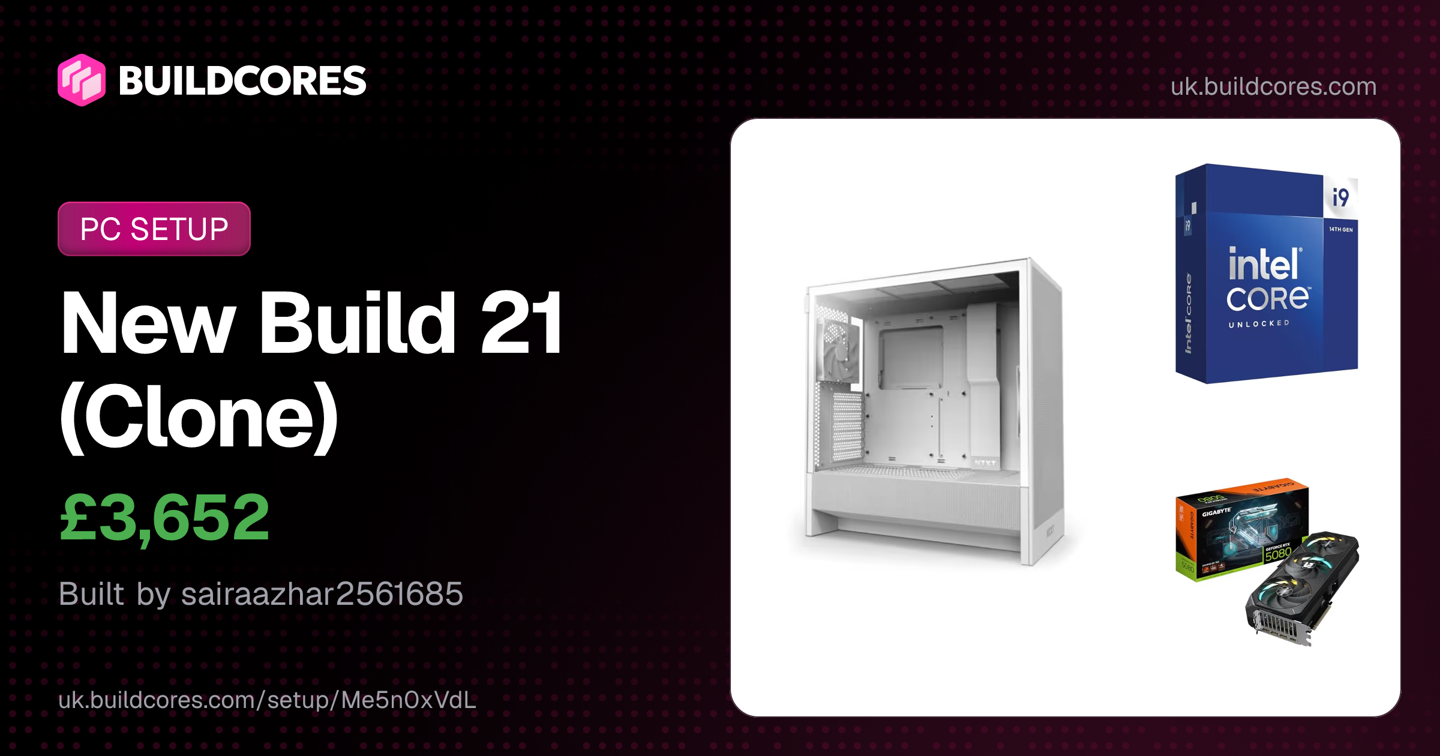
Component | Title | Price | Justification
Mousepad | SteelSeries QcK Prism Cloth XL RGB Gaming Mouse Pad - Black | £43.99 (ScanComputer) | This desk mouse mat provides a comfortable and smooth surface for moving the mouse easily and smoothly.
Headphones | HyperX Cloud III Wired - White | £69.99 (Amazon) | These headphones have a noise-canceling microphone that helps make calls, meetings, or video projects smooth and tension-free. One more thing, their soft ear cushions help protect ears from pain and provide nice voice quality.
Mouse | Razer DeathAdder V3 Pro Wireless Optical Gaming Mouse Black | £79.97 (Amazon) | This mouse is wireless, so it does not cause placement and wire adjustment issues while doing big projects, drawing big pictures, or taking large screenshots. It works very smoothly and has high DPI control.
Webcam | Logitech 4k Webcam | £110.99 (BackToTheOffice) | This webcam provides a clear 4K camera that makes video calls smooth. It is really essential for presenting 3D models to clients as well as making video calls. The good thing is it automatically adjusts quality even in dark or low room lighting.
Monitor | KOORUI 27E1QA 27" 1440p 144Hz VA Monitor | £125.00 (Computer Orbit) | This monitor has a 27-inch screen that provides high resolution and a fast refresh rate. It is perfectly suitable for 3D PC work and gives enough screen space for detailed rendering tasks. It also shows a smooth display.
Keyboard | Redragon K745 Wired Gasket RGB Gaming Keyboard, 108 Keys Mechanical Keyboard w/Extra 4 Hotkeys, Upgraded Hot-swappable Socket, 5-Layer Noise Dampening, Creamy & Thocky Custom Linear Switch | £55.40 (Amazon) | This mechanical keyboard is a nice choice for typing data without tiring out the user, and it works well with high-end 3D PCs.
Case | NZXT H5 Flow (2024) ATX Mid Tower White with Tempered Glass Side Panel and USB 3.2 Gen 2x2 Type-C USB 3.2 Gen 1 Type-A | £58.95 (Amazon) | This case contains big panels on the front and bottom sides, and this is a really good thing because air flows into the PC through them. 3D rendering computers work for long hours. The main parts produce a lot of heat, so these panels help these PCs cool down and work fast. One more thing, this case comes with an ATX size that provides more space to use heavy/large parts like the motherboard and graphics card, and can also be upgraded in the future.
CPU | Intel Core i9-14900K | £422.50 (Amazon) | As everyone knows, the CPU is the brain of the computer, and the good thing is the chosen CPU provides 24 processing cores that work really fast. 3D rendering workstations usually work on heavy and complicated projects that sometimes make these PCs slow down and freeze. Having 24 cores is the specialty of this CPU because it makes the computer fast and smooth, as a big project is considered divided into 24 smaller tasks.
Motherboard | MSI PRO Z790-A WIFI II LGA1700 DDR5 ATX | £211.09 (Amazon) | The motherboard is the main circuit board of the computer where all the parts of the PC connect, and it is responsible for supplying power to those parts. This motherboard is a good choice for 3D rendering work because it provides a good amount of power and supports fast DDR5 memory, which handles large 3D PC projects easily and efficiently. It also contains built-in Wi-Fi and ports that help share large files in seconds without long waits.
GPU | Gigabyte GeForce RTX 5080 GAMING OC 16G GDDR7 | £1,369.99 (Overclockers) | The GPU is the most important part of a 3D rendering PC. This graphics card is a nice choice for a 3D rendering PC because it provides 16GB of VRAM that supports high performance and gives good and smooth textures. It also has RT cores that provide good lighting and 3D effects fast in minutes instead of taking long hours.
RAM | ADATA XPG LANCER RGB White 32GB (2x16GB) DDR5 6000 CL30 | £424.99 (Overclockers) | This chosen memory is really fast. Every software responds in seconds without long delays, and multiple applications open and work quickly at the same time. This memory is far better than old used memories and works best for 3D rendering. In the future, it can be upgraded to 64GB.
CPU Cooler | NZXT Kraken Elite 360 RGB White (2024) | £229.99 (Amazon) | This is the CPU cooler that uses a liquid pump and consists of a 360mm radiator (fans) that helps make large computers like 3D rendering PCs cool down. It protects 3D rendering PCs from overheating. The main part of this CPU cooler is that it contains a built-in screen that shows the live temperature of the CPU and GPU.
Storage | Kingston KC3000 2TB SSD M.2 PCIe 4.0 NVMe | £308.40 (Box.co) | The chosen storage is an ultra-fast drive that works very quickly. It helps turn on the PC in seconds and load complex 3D projects easily. It also opens multiple programs at once. This storage is a suitable choice for a 3D rendering PC. It also provides a 2TB capacity, which is actually enough space for saving large rendering files.
Power Supply | Seasonic Focus V4 GX-1000 Fully Modular ATX Power Supply - 1000 Watts ATX 3.1 - White | £129.00 (Computer Orbit) | This power supply gets electricity from a wall outlet and provides it to the parts of the computer. A PC needs a lot of power while doing rendering work, so 1000W gives it enough power to work nicely even on full load without shutting down. It also gives an 80 Plus Gold rating that helps the computer waste less energy and saves money.
Case Fan | Arctic P12 Pro PST 120 White PWM | £5.99 (ScanComputer) | These are 120mm fans that push air into the case. They work by pulling cool air into the computer and pushing warm air out from the computer while doing heavy rendering, which makes the PC's temperature stable. These things keep other parts of the computer safe and make them last long.
Case Fan | Arctic P12 Pro PST 120 White PWM | £5.99 (ScanComputer) | These are 120mm fans that push air into the case. They work by pulling cool air into the computer and pushing warm air out from the computer while doing heavy rendering, which makes the PC's temperature stable. These things keep other parts of the computer safe and make them last long.
Cable Extension | EZDIY-FAB 12VHPWR PSU Extension Kit (All White) | £34.99 (Amazon) | This power cable is actually made for heavy graphics cards. As we know, graphics cards need a good amount of power, so it works well and provides energy without sharp bends and damaging anything. It keeps the case clean this way, so all parts inside get nice airflow.
Ethernet Cable | DDMALL 3m 2 Pack Cat 8 Ethernet Cable (Black) | £14.99 (Amazon) | This is a fast network cable. 3D rendering PCs handle large files, and this cable really helps in uploading, downloading, and sharing huge 3D projects quickly without long waits. The important thing is its internal shield tries to stop all kinds of internet interference so the connection does not drop off.
HDMI Cable | Snowkids 10K 8K HDMI 2.1 Cable 2M Certified | £5.31(Amazon) | This cable is a high-quality display cable that is able to carry 8K resolution video signals. It sends a clear picture signal from the graphics card to the monitor.
Power Strip | HAFINO Tower Extension Lead (Grey and White) | £24.63 (Amazon) | This vertical power strip consists of multiple sockets and surge protection. It also helps protect expensive parts of the PC from sudden spikes of electricity. Its good thing is its vertical shape that takes small space on the desk and does not spread a mess around the PC.
Total Price | £3,732.15
BuildCores Web | BuildCores iOS | BuildCores Android

HAMZA
Component | Title | Price | Justification
Case | Fractal Design North XL ATX Full Tower Black with Tinted Tempered Glass Side Panel and USB 3.2 Gen 2 Type-C, USB 3.2 Gen 1 Type-A | £148.99 (Amazon) | This case has excellent airflow and plenty of space for large components. It keeps the system cool during heavy workloads. It is stronger and more spacious than many standard PC cases. It is ideal for professional workstation builds.
CPU | AMD Ryzen 7 9700X | £244.99 (Overclockers) | The Ryzen 7 9700X provides fast processing with excellent multi-tasking performance. It is more power-efficient than many older CPUs while delivering strong performance. It is suitable for CAD, rendering, and engineering applications. It can handle multiple workstation tasks smoothly.
Motherboard | ASUS X870E ROG CROSSHAIR EXTREME AM5 DDR5 EATX | £744.99 (Box.co) | motherboard offers advanced features, strong power delivery, and future upgrade support. It provides better stability and connectivity than basic motherboards. It is designed for high-performance systems. It supports demanding workstation workloads reliably.
GPU | ASRock AMD Radeon RX 9070 XT Challenger 16GB | £719.99 (Overclockers) | This graphics card delivers powerful 3D rendering and graphics performance. The 16GB memory helps with large CAD and design projects. It performs better than many mid-range GPUs. It is ideal for professional workstation applications.
RAM | Corsair Vengeance RGB 64GB (2x32GB) DDR5 6000 CL30 White | £976.99 (Corsair UK) | The 64GB memory allows smooth multitasking and handling of large files. DDR5 technology provides faster performance than older DDR4 memory. It reduces slowdowns when running multiple applications. It is suitable for demanding workstation tasks.
CPU Cooler | TRYX HOLO ARGB 360mm Liquid Cooler Black | N/A (Amazon) | This liquid cooler keeps the processor temperature low under heavy workloads. It provides better cooling than many air coolers. Lower temperatures improve system stability and performance. It is useful for long workstation sessions.
Storage | Samsung 9100 PRO 4TB M.2-2280 SSD PCIe 5.0 NVMe | £880.99 (CCL) | This SSD provides very fast loading and file transfer speeds. The 4TB capacity offers plenty of space for large projects and software. It is faster than traditional hard drives and many older SSDs. It improves overall workstation efficiency.
Power Supply | Corsair RM750x SHIFT Black Side Interface 750W Fully Modular 80+ Gold Certified | £134.99 (Corsair UK) | This power supply delivers stable and efficient power to all components. It is more reliable than lower-quality power supplies. The fully modular design improves cable management. It helps maintain system stability during heavy workloads.
Case Fan | Lian Li Uni Fan SL-Infinity PWM ARGB 120mm White Pack of 3 | £78.22 (Amazon) | These fans improve airflow and cooling throughout the system. Better airflow helps maintain stable performance during intensive tasks. They are quieter and more efficient than many standard fans. They support long workstation operating hours.
Keyboard | ASUS ROG Azoth Extreme RGB Wireless ROG NX Snow Gaming Keyboard | £607.15 (Amazon) | This keyboard offers comfortable typing and durable build quality. It provides a better user experience during long working sessions. The wireless design keeps the workspace clean. It is suitable for professional workstation use.
Webcam | Insta360 Link 2 - PTZ 4K Webcam for PC/Mac, 1/2" Sensor, AI Tracking, HDR, AI Noise-Canceling Mic, Gesture Control for Streaming, Video Calls, Gaming, Works with Zoom, Teams, Twitch & More | £199.99 (Amazon) | This webcam provides high-quality 4K video for meetings and presentations. AI tracking keeps the user in frame automatically. It offers better image quality than standard webcams. It is useful for remote collaboration and online communication.
Mouse | LAMZU MAYA X Charcoal Black | £134.05 (Amazon) | This mouse is lightweight, accurate, and comfortable to use. It provides precise control for design and productivity work. It is more responsive than many basic office mice. It supports efficient workstation operation
|Total Price|$4871.34| |

SHAYKHALDIN

BuildCores Parts List: Link
Member | Build Area Owned | What they'll deliver
shayk | Administrative Assistant | I

Component | Title | Price
Case | MONTECH XR Panoramic High Airflow ATX PC Case, 3 ARGB PWM Fans, White | £49.99 (ScanComputer)
CPU | AMD Ryzen 5 5500 | £74.99 (Overclockers)
Motherboard | Gigabyte A520 M K V2 AM4 DDR4 Micro ATX | £43.97 (Amazon)
GPU | ASUS Prime Radeon™ RX 9060 XT 8GB GDDR6 OC Edition | £349.99 (ScanComputer)
RAM | Corsair Vengeance LPX 16GB (2x8GB) DDR4 3200 CL16 Black | £139.99 (Overclockers)
CPU Cooler | Thermalright Assassin X 120 Refined SE Air 120mm Black / Silver | £15.00 (Computer Orbit)
Storage | Western Digital Caviar Blue 1TB 3.5" HDD 7200RPM SATA 6.0 Gb/s | £58.00 (Amazon)
Power Supply | MSI MAG A650GL Black 650W Fully Modular 80+ Gold Certified ATX | £70.99 (CCL)
Case Fan | Lian Li Uni Fan SL-Infinity 140mm ARGB PWM Reverse | £25.98 (Box.co)
Webcam | NexiGo N60 1080p Webcam | £31.99 (Amazon)
Mouse | Logitech M220 Wireless Mouse with Silent Clicks | £11.99 (Box.co)
Total Price | £872.88
BuildCores Web | BuildCores iOS | BuildCores Android

SQL

HAMZA
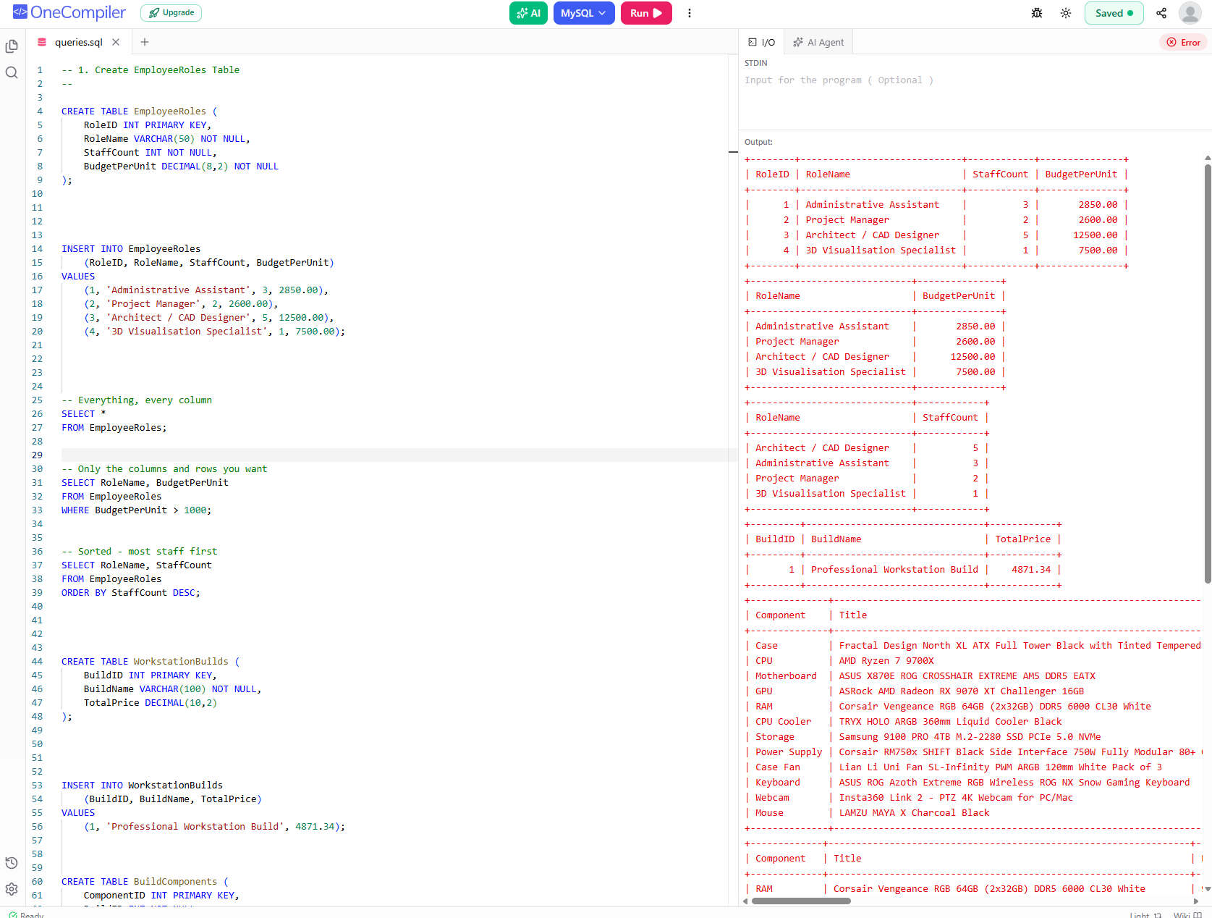
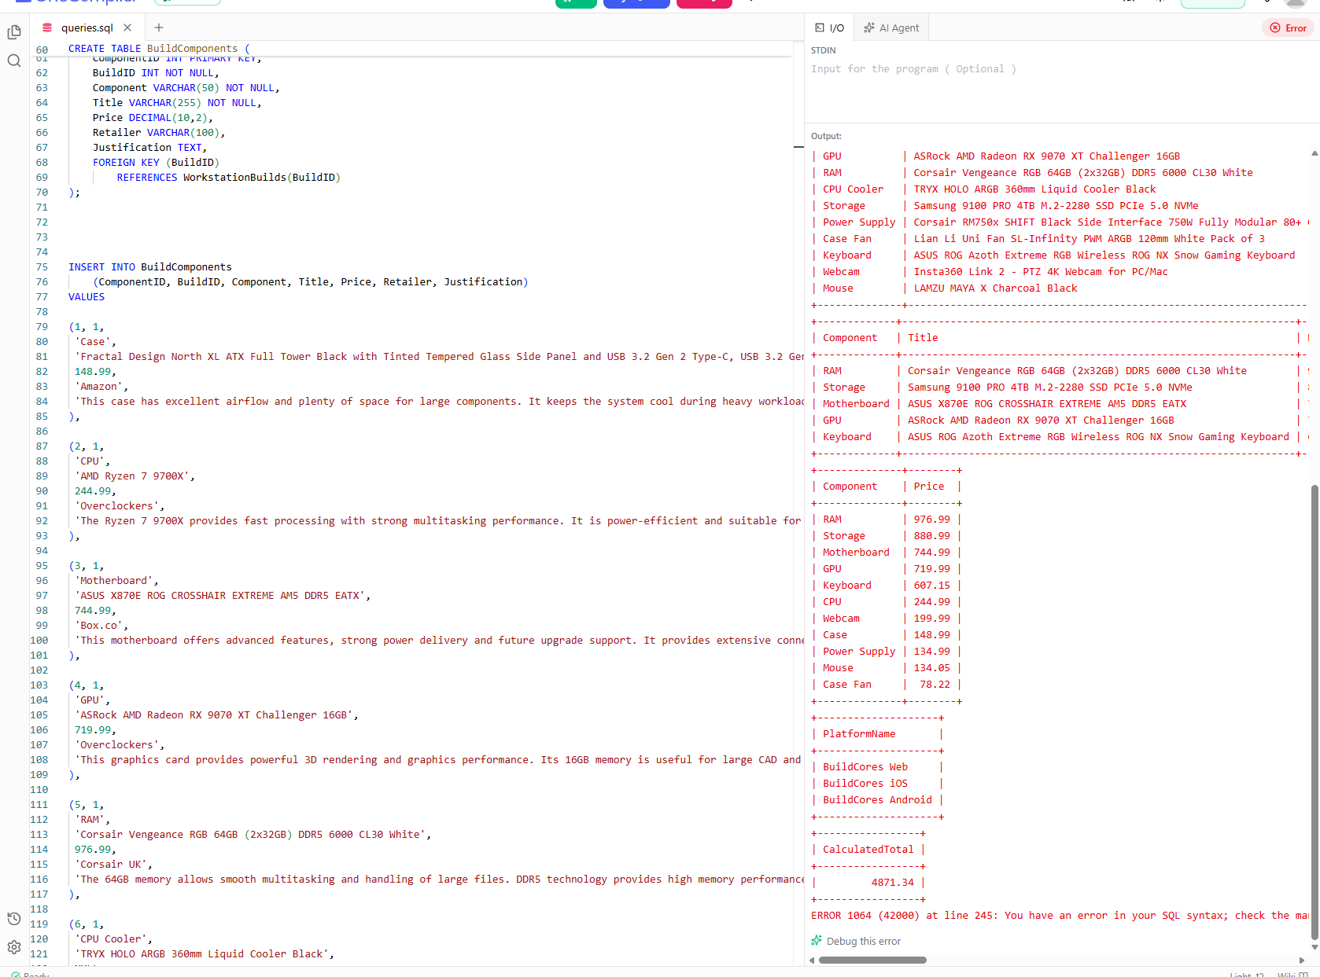
SAIRA
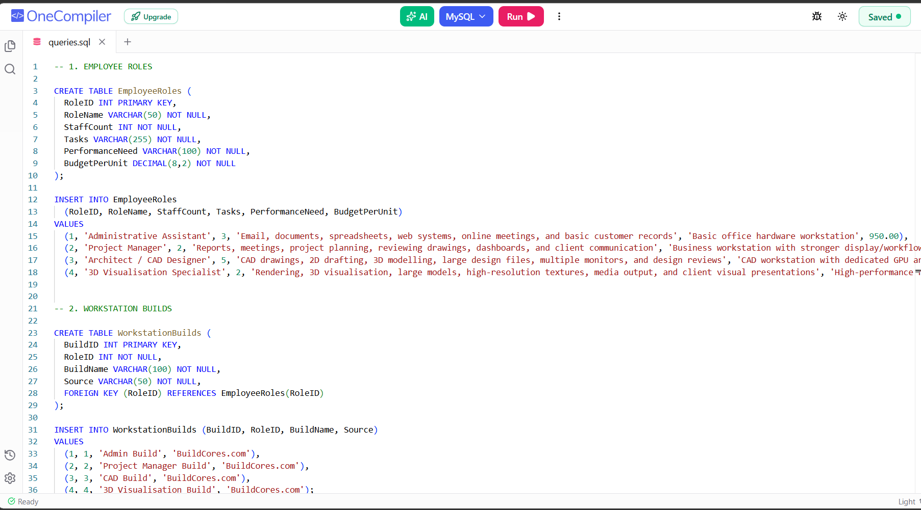

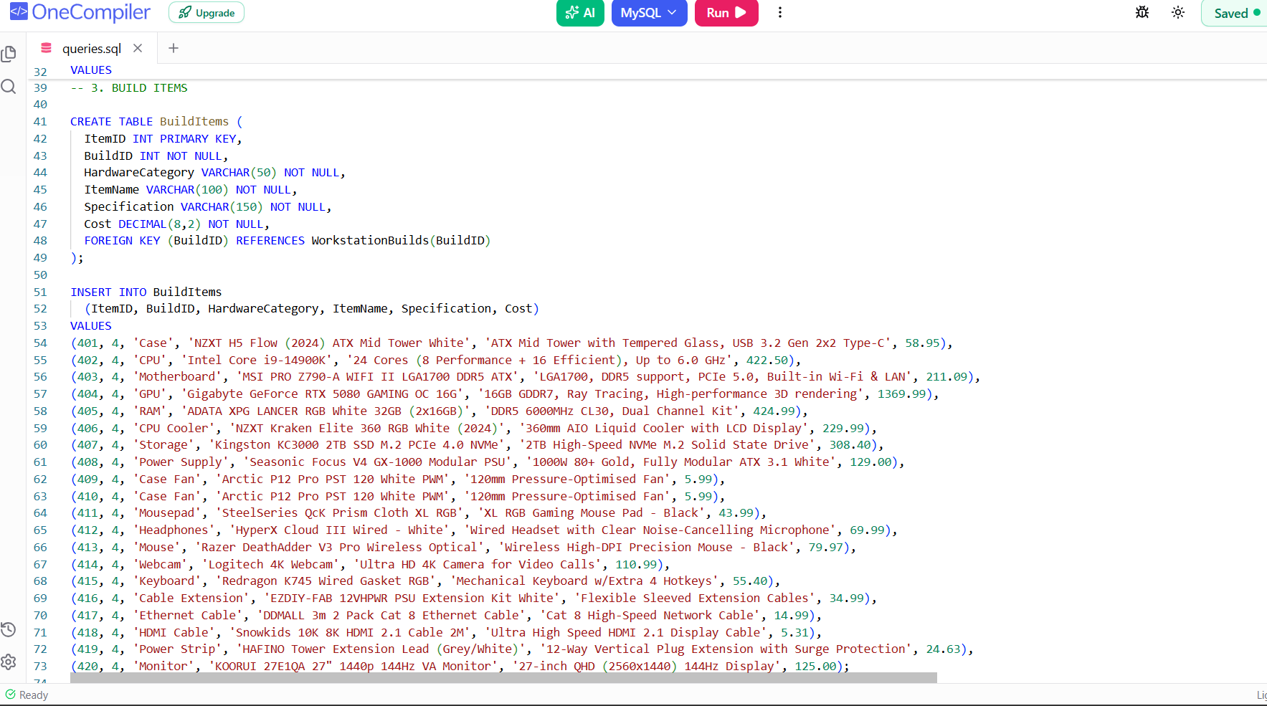
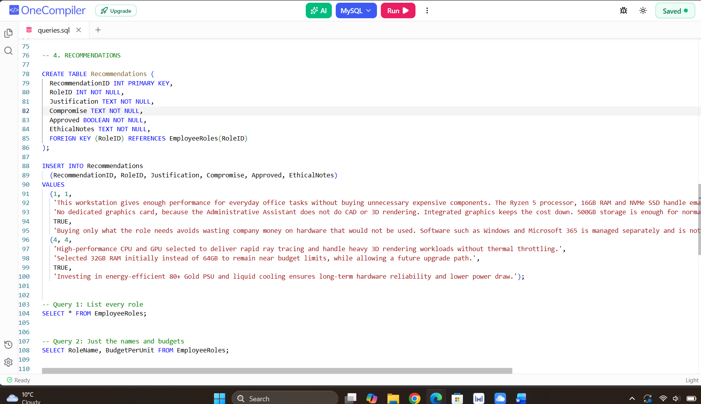

SHAYKH
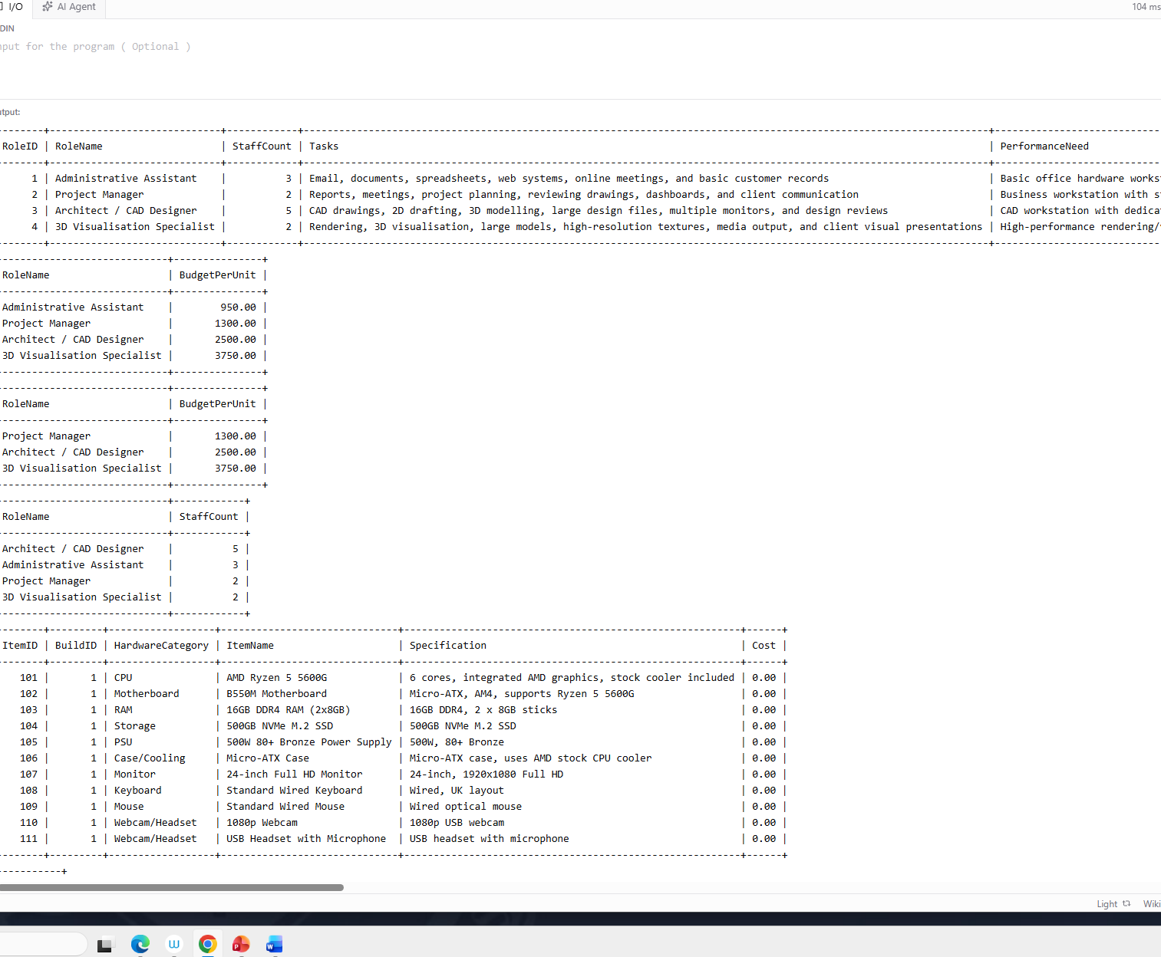

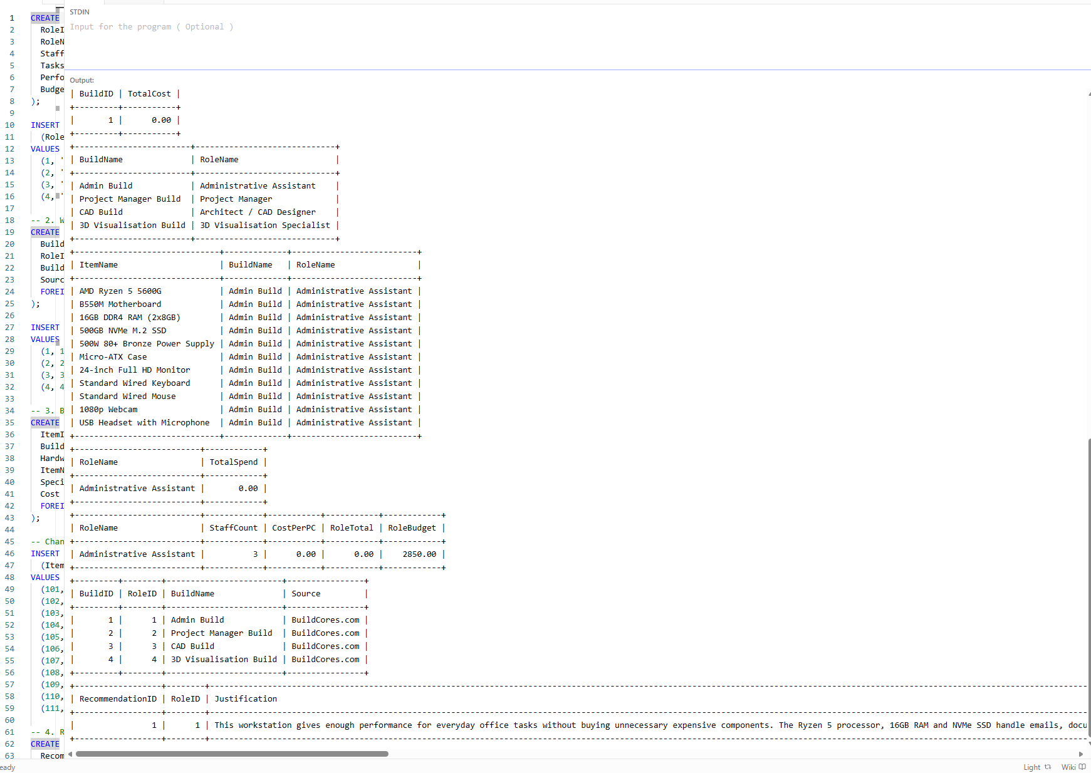
https://onecompiler.com/mysql/455nzqyrk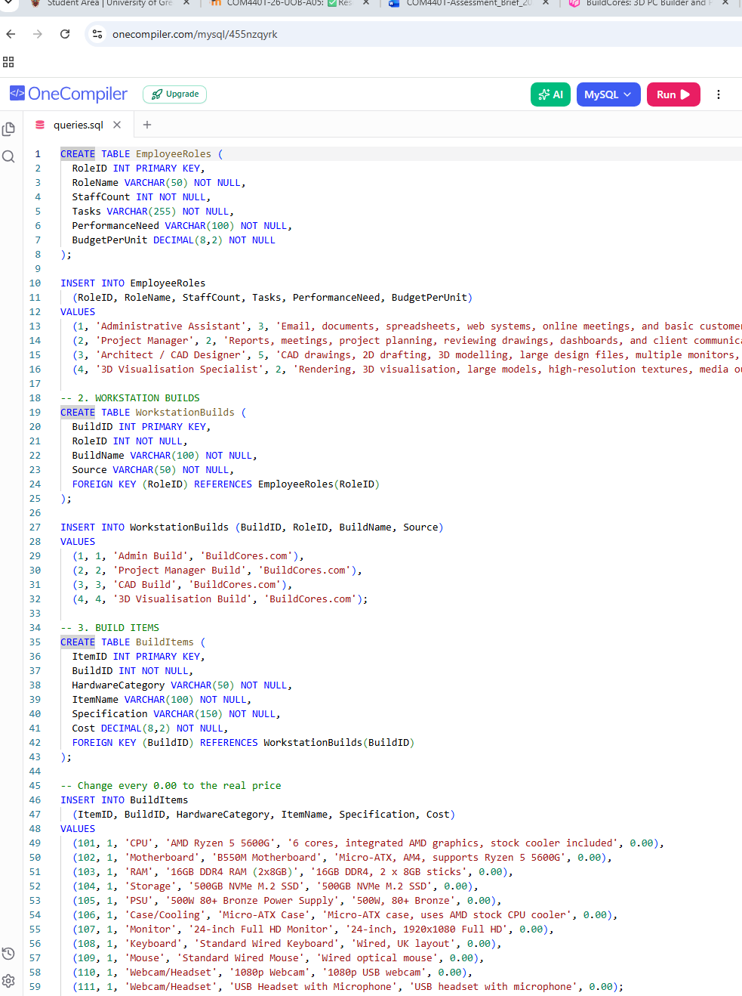

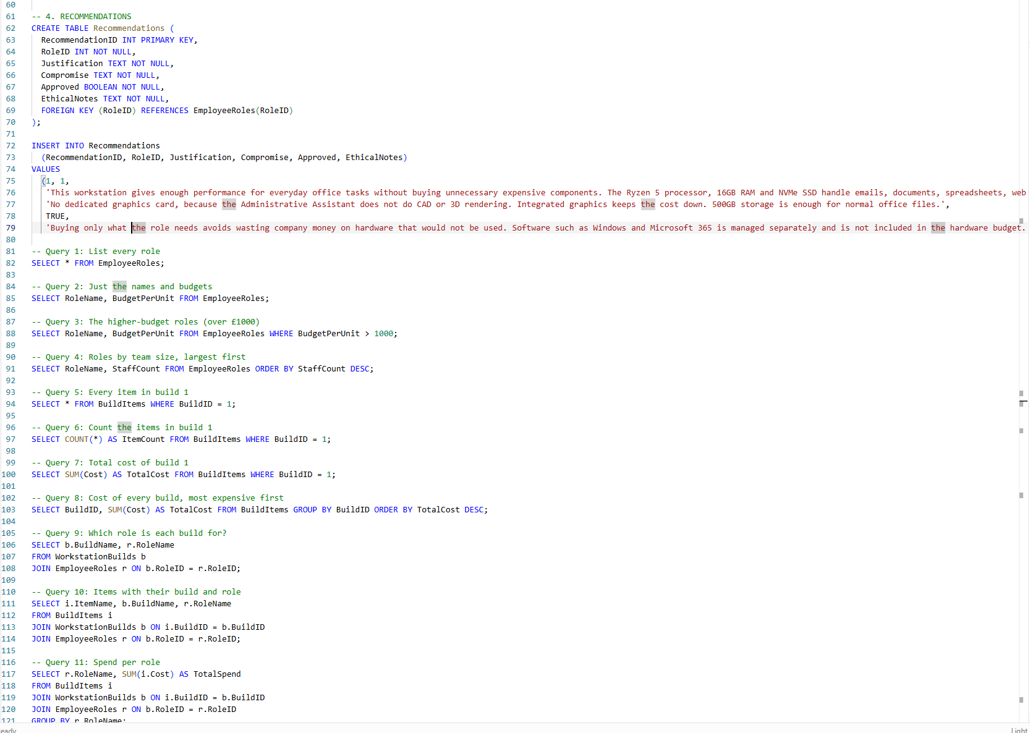
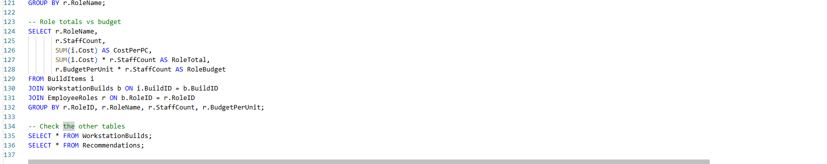
https://onecompiler.com/mysql/455nzqyrk

